SET 22: TIME SERIES ANALYSIS
Dataset: Monthly Sales Data
Dataset
Month | Sales (in $)
January | 15,000
February | 18,000
March | 22,000
April | 20,000
May | 23,000
1. Time Series Line Chart in R
Question: In R, create a time series line chart to visualize the trend in monthly sales. Label the axes and title the chart.
Aim: To visualize the monthly sales trend and identify increases or decreases over the five months.
Code:
library(ggplot2)
sales <- data.frame(
Month = factor(c("January", "February", "March", "April", "May"),
levels = c("January", "February", "March", "April", "May")),
Sales = c(15000, 18000, 22000, 20000, 23000)
)
ggplot(sales, aes(x = Month, y = Sales, group = 1)) +
geom_line(colour = "blue", linewidth = 1) +
geom_point(colour = "red", size = 3) +
labs(title = "Monthly Sales Trend",
x = "Month", y = "Sales (in $)") +
theme_minimal()
Output :
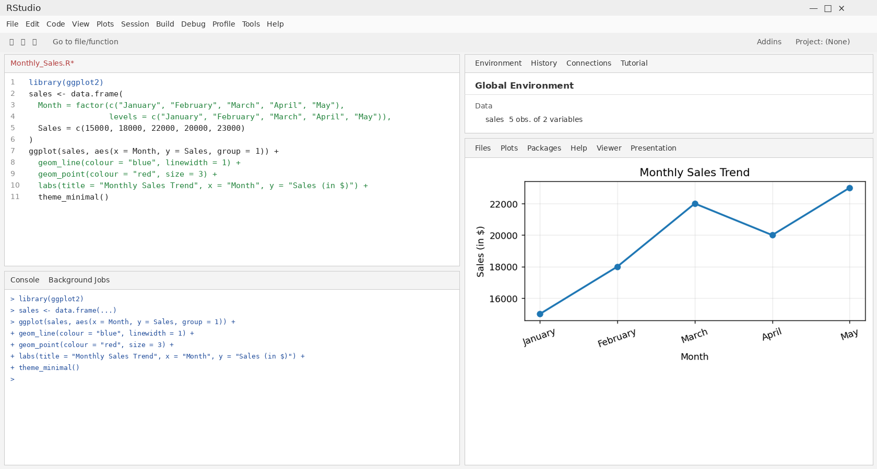
Result: The chart shows overall growth from $15,000 in January to $23,000 in May. Sales dip in April before reaching the highest value in May.

2. Scatter Plot: Advertising Budget and Monthly Sales
Question: In R, generate a scatter plot to analyze the relationship between advertising budget and monthly sales. Explain any insights.
Aim: To examine whether higher advertising expenditure is associated with higher monthly sales.
Code:
library(ggplot2)
ad_data <- data.frame(
Month = c("January", "February", "March", "April", "May"),
Advertising = c(2000, 2500, 3000, 2800, 3500),
Sales = c(15000, 18000, 22000, 20000, 23000)
)
ggplot(ad_data, aes(x = Advertising, y = Sales)) +
geom_point(colour = "darkgreen", size = 3) +
geom_smooth(method = "lm", se = FALSE, colour = "blue") +
labs(title = "Advertising Budget vs Monthly Sales",
x = "Advertising Budget (in $)", y = "Sales (in $)") +
theme_minimal()
Output :
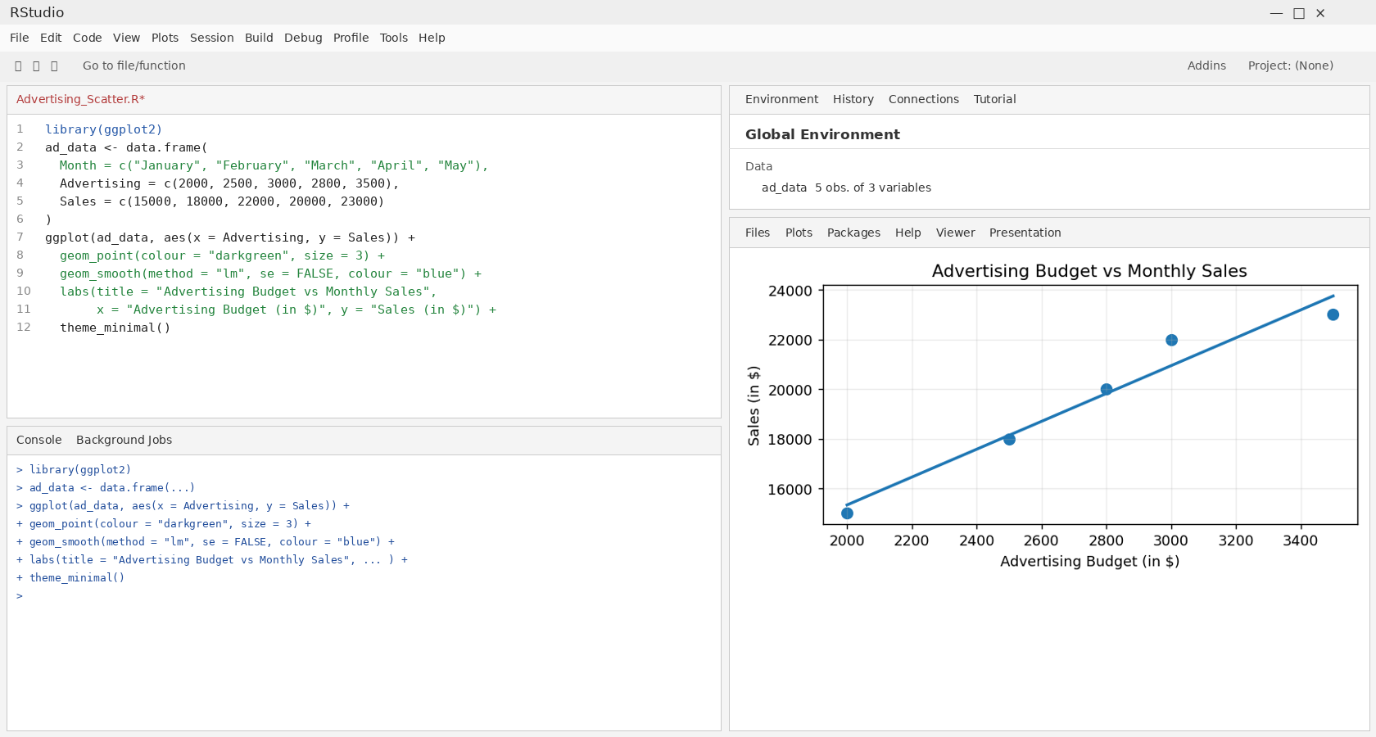
Result: The example points show a generally positive association between advertising budget and sales. Advertising values are illustrative because the question does not supply them.

3. Tableau Dashboard: Sales Trend and Product Distribution
Question: In Tableau, build a dashboard combining a line chart showing sales trend and a pie chart displaying the distribution of sales across products.
Aim: To combine monthly sales movement and product-wise sales share in one dashboard.
Output :
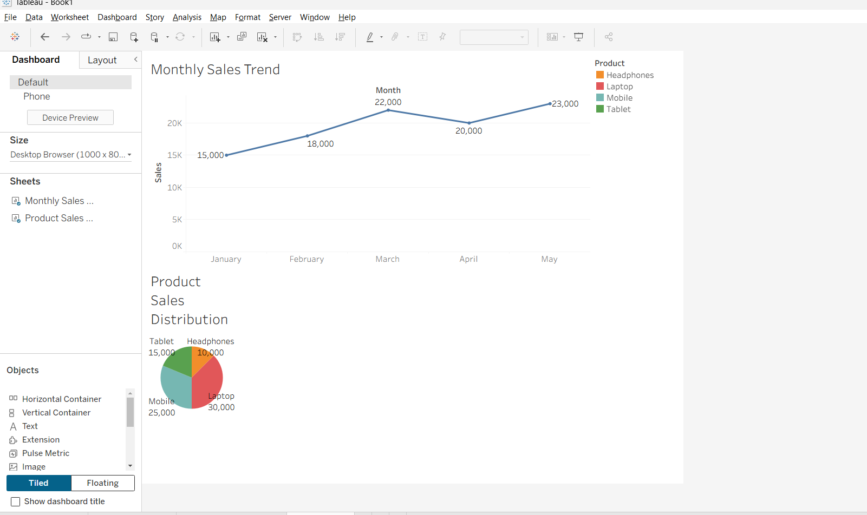

Result: The preview combines a monthly line chart and a product-share pie chart. Product shares are illustrative because product-level sales data was not provided.

4. Autocorrelation Plot in R
Question: In R, create an autocorrelation plot to identify seasonality in the time series data.
Aim: To examine correlations between sales at different time lags and check for repeated patterns.
Code:
sales_values <- c(15000, 18000, 22000, 20000, 23000)
sales_ts <- ts(sales_values, frequency = 12, start = c(2026, 1))
acf(sales_ts,
main = "Autocorrelation of Monthly Sales",
xlab = "Lag",
ylab = "Autocorrelation")
Output :
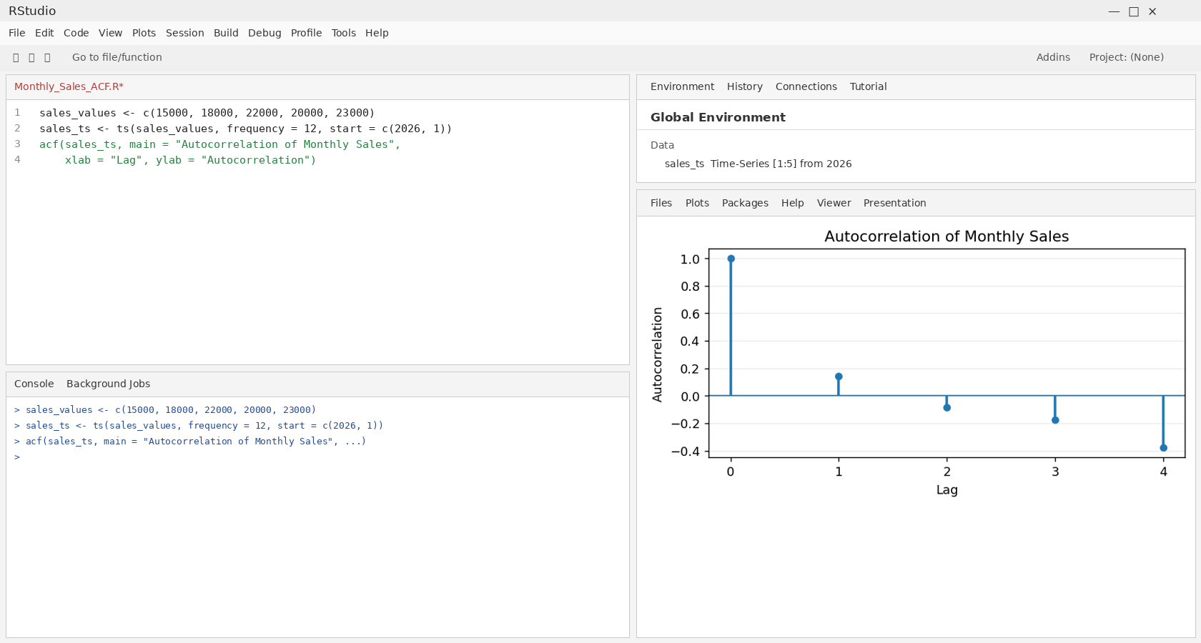
Result: The ACF plot shows correlations at available lags. Five observations are not enough to establish reliable seasonality; several years of monthly data are recommended.

